**اللهم علمنا ما ينفعنا، وانفعنا بما علمتنا، وزدنا علما "سُبْحَانَكَ لا عِلْمَ لَنَا إِلَّا مَا عَلَّمْتَنَا إِنَّكَ أَنْتَ الْعَلِيمُ الْحَكِيم"**

* **Lecture 1**

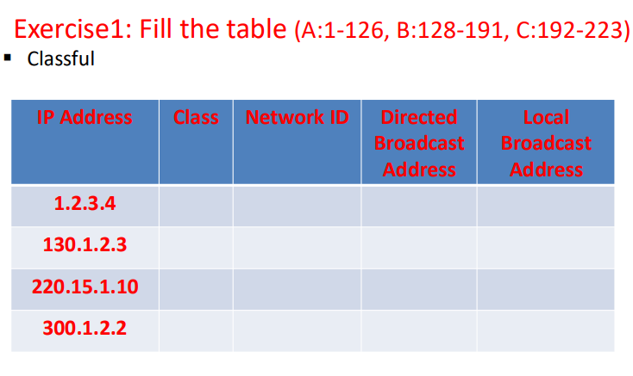

|  |  |  |  |  |
| --- | --- | --- | --- | --- |
| IP Address | Class | Network ID | Directed Broadcast Address | Local Broadcast Address |
| 1.2.3.4 | **A** | **1.0.0.0** | **1.255.255.255** | **255.255.255.255** |
| 130.1.2.3 | **B** | **130.1.0.0** | **130.1.255.255** | **255.255.255.255** |
| 220.15.1.10 | **C** | **220.15.1.0** | **220.15.1.255** | **255.255.255.255** |
| 300.1.2.2 | **N/A** | **Invalid IP** | **N/A** | **N/A** |

**Exercise2: Find all IPs in this CIDR Block**

**▪ Classless**

**▪ 100.1.2.35/28**

**▪ Check whether 100.1.2.32 to 100.1.2.47 is a valid IP address block or not?**

**Step 1: Identify all IPs in the CIDR block 100.1.2.35/28**

**- CIDR Block: 100.1.2.35/28**

**- /28 CIDR notation means there are 32 - 28 = 4 bits left for host addresses.**

**- 2^4 = 16 addresses in total for this subnet.**

**- Subnet Range Calculation**

**- Subnet mask: 255.255.255.240**

**- Network address for 100.1.2.35/28 is 100.1.2.32 (this is the start of the range)**

**- Broadcast address is 100.1.2.47 (this is the end of the range).**

**- List of IP Addresses:**

**100.1.2.32 - Network address**

**100.1.2.33**

**100.1.2.34**

**100.1.2.35**

**100.1.2.36**

**100.1.2.37**

**100.1.2.38**

**100.1.2.39**

**100.1.2.40**

**100.1.2.41**

**100.1.2.42**

**100.1.2.43**

**100.1.2.44**

**100.1.2.45**

**100.1.2.46**

**100.1.2.47 – Broadcast address**

**Step 2: Check if 100.1.2.32 to 100.1.2.47 is a valid IP block**

1. **Range is continuous**
2. **Number of Hosts = 47 – 32 = 16 (size of the block is power of 2)**
3. **First ip in range (100.1.2.32) is divisible by the size of the block**

**00100000 ----------- > 32**

**00010000 ----------- > 16**

**Exercise 3:**

1. **Compress the following IPv6 addresses**

**▪ fd20:1400:0000:0400:1000:0000:0000:9200**

**fd20:1400:0:400:1000::9200**

**▪ fd02:0000:2580:8c32:0100:0090:0008:0042**

**fd02:0:2580:8c32:100:90:8:42**

1. **Expand the following IPv6 addresses**

**▪ fd00:8400::840:3000:42:1000**

**fd00:8400:0000:0000:0840:3000:0042:10000**

**▪ fd62::a082:1018:0:0:a200**

**fd62:0000:0000:a082:1018:0000:0000:a200**

**__________________________________________________________________________________**

* **Lecture 4**
* Find the MAC address correlated with the following Multicast IP Addresses:

1. **225.5.6.7**

**1110 0001 0000 0101 0000 0110 0000 0111**

**XXXX 0 000 0101 0000 0110 0000 0111**

**01-00-5E-05-06-07**

1. **225.1.1.1**

**1110 0001 0000 0001 0000 0001 0000 0001**

**XXXX 0 000 0001 0000 0001 0000 0001**

**01-00-5E-01-01-01**

1. **225.129.1.1**

**1110 0001 1000 0001 0000 0001 0000 0001**

**XXXX 0 000 0001 0000 0001 0000 0001**

**01-00-5E-01-01-01**

1. **225.129.1.2**

**1110 0001 1000 0001 0000 0001 0000 0010**

**XXXX 0 000 0001 0000 0001 0000 0010**

**01-00-5E-01-01-02**

* Which of the following multicast IP addresses is mapped to the multicast MAC address 01:00:5e:0b:01:02

1. **225.5.6.7**

**01-00-5E-05-06-07**

1. **224.11.1.2**

**1110 0000 0000 1011 0000 0001 0000 0010**

**XXXX 0 000 1011 0000 0001 0000 0010**

**01-00-5E-0b-01-02**

1. **225.129.1.1**

**01-00-5E-01-01-01**

1. **229.11.1.2**

**1110 0101 0000 1011 0000 0001 0000 0010**

**XXXX 0 000 1011 0000 0001 0000 0010**

**01-00-5E-0b-01-02**

1. **Answer: (224.11.1.2, 229.11.1.2) mapped to 01:00:5e:0b:01:02**

**____________________________________________________________________________**

* **Lecture 5**
* Classify the following MAC addresses into unicast, multicast, and broadcast.

1. 4A-30-10-19-10-1A > **unicast**
2. 08-00-27-EC-10-61 > **unicast**
3. 01-00-5E-00-01-01 > **multicast**
4. FF-FF-FF-FF-FF-FF > **broadcast**
5. 38-00-5E-02-31-11 > **unicast**
6. 01-00-5E-A2-FE-FF > **unicast**
7. A MAC address with first MSB as xxxx xxx1 >

**May be multicast or broadcast**

1. A MAC address with first two MSBs as xxxx xxx1:0101 1010 >

**May be multicast**

* **Exercise 2**

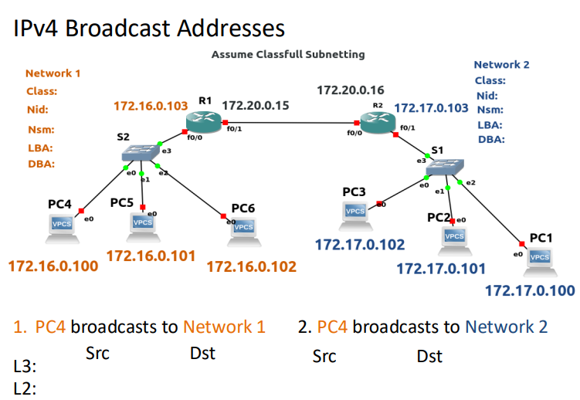

1. **PC4 broadcast to network 1**

**L3: Src Dst**

172.16.0.100 255.255.255.255 or 172.16.255.255

**L2: Src Dst**

PC4 Mac FF:FF:FF:FF:FF:FF

1. **PC4 broadcast to network 2**

**L3: Src Dst**

172.16.0.100 172.17.255.255

**L2: Src Dst**

PC4 Mac R1 Mac